**The Product Recommendation for H&M**

Course: BIA 679

Member: Tengyue Chen, Hao Miao, Haoxing Zhang

**I. Introduction**

Online shopping has become one of the shopping channels for consumers with the development of the Internet. Total e-commerce sales in 2021 are expected to be $870.8 billion and grow 14.2% from 2020 (Young, 2022) in the U.S. Many online shopping companies have grown into well-known global companies, such as Amazon, Ebay, and Alibaba. However, with the increase in the number of items on online shopping platforms or websites. However, because the number of products on online shopping platforms continues to increase, the users may not choose their favorite products.

Recommend systems provide users with product information to help users make decisions and complete online purchases. The E-commerce recommendation system builds models that reflect user attributes and behaviors through the collected user information (Zhao, 2019). Online shopping platforms could use the E-commerce recommendation model in the backend to help users quickly find their favorite products.

This project attempts to build a model based on the dataset of products and user behavior provided by H&M. This model could predict the user's potential product selection and provide purchase suggestions through the user's previous purchase behavior or habits. Because real-time data cannot be obtained, the model of this project will focus on offline recommendation. The figure 1 shows the design of the recommendation model system.

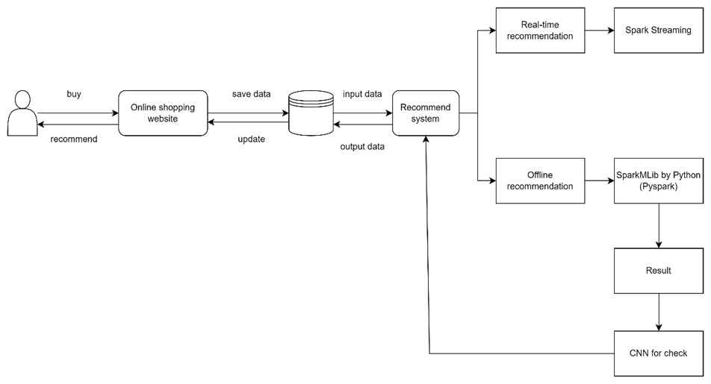

Figue1. Model Design

**II. Data collection**

The dataset is collected from the Kaggle(<https://www.kaggle.com/competitions/h-and-m-personalized-fashion-recommendations/data>). The dataset contains the purchase history of H&M customers in the online store. The dataset contains three files, includes product pictures, product purchase records, and user information. Table 1, table2, and table 3 show the dataset columns.

|  |  |
| --- | --- |
| Columns | Feature |
| article_id | The article id |
| product_code | The code of product |
| prod_name | The name of product |
| product_type_no | The number of product type |
| product_type_name | The name of product name |
| product_group_name | The group name of product |
| graphical_appearance_no | The number of graphical appearances |
| graphical_appearance_name | The name of graphical appearances |
| colour_group_name | The name of color group |
| perceived_colour_value_id | The value id for perceived color |
| perceived_colour_master_id | The master id for perceived color |
| perceived_colour_master_name | The master’s name for perceived color |
| department_no | The number of departments |
| department_name | The name of departments |
| index_code | The index code |
| index_name | The name of index |
| index_group_no | The number of index group |
| index_group_name | The name of index group |
| section_no | The number of sections |
| section_name | The name of section |
| garment_group_no | The number of garment group |
| garment_group_name | The name of garment group |
| detail_desc | The detail describes |

Table 1. Columns of articles

|  |  |
| --- | --- |
| Columns | Feature |
| customer_id | The customer id |
| FN |  |
| Active | Active or not active |
| club_member_status | The status of club member |
| fashion_news_frequency | The frequency of fashion news |
| age | The customer age |
| postal_code | The customer’s postal code |

Table 2. Columns of customer

|  |  |
| --- | --- |
| Columns | Feature |
| t_dat | The date about the transactions |
| Customer_id | The customer id |
| Article_id | The article id |
| price | The price about the transactions |
| Sales_channel_id | The sales channel id |

Table 3. Columns of transactions

**III. Project Timeline**

The project will be completed through 8 milestones. The Figure 2 show that the timeline about this project. In the week 1, the project’s goal is established. In the second week, suitable datasets were searched. After, we clean the data in the third week. In weeks 4 to 5, we analyze the obtained dataset. We plan to present our results in week 6. In week 7 we review the project and check the error. Week 8, we finish the whole project and summarize it. The table 4 show the detail about the project timeline.

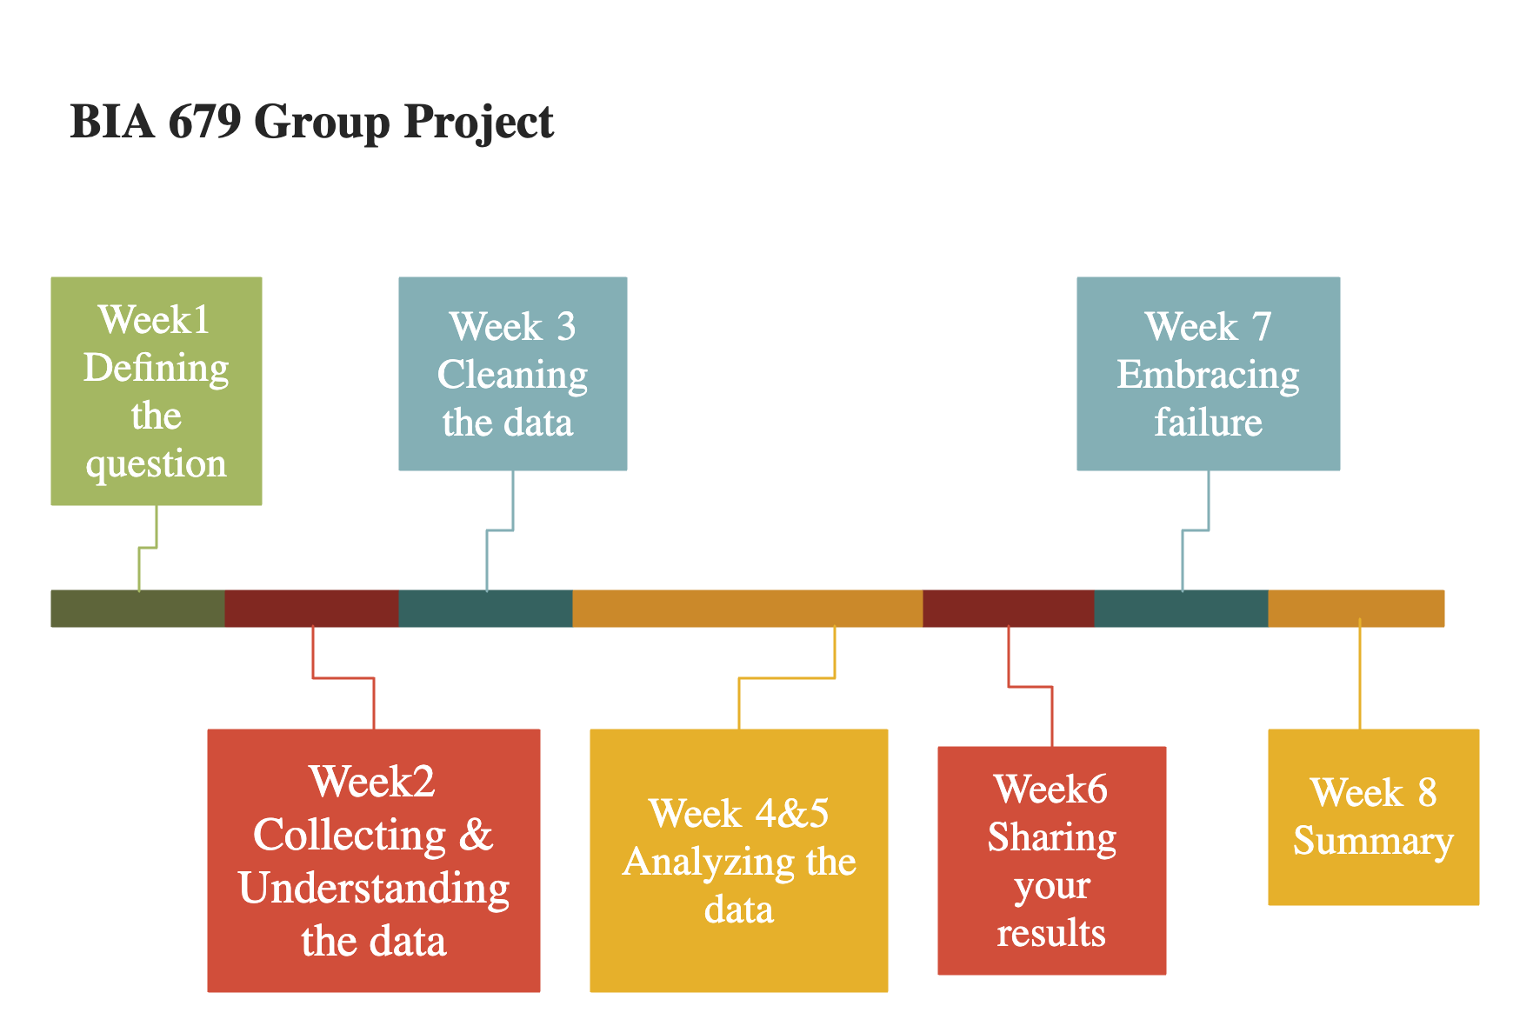

Figure 2. Project Timeline

|  |  |
| --- | --- |
| Week | Detail |
| 1 | The group discuss about the topic and goal about the project. |
| 2 | A dataset is found or collected basic on the project.  The group try to understand the dataset. |
| 3 | The group clean the dataset.  The EDA is finished by the following step:  1. Statistics on product filter by time, amount, etc  2. Statistics on customer filter by id, age, etc  3. Transaction amount by date  4. Correlation between customer and product  5. Word Cloud |
| 4 | The group start to analyze the data.  The Apache Spark is installed  The group try to learn the Spark.  Using the PySpark to build an ALS model. |
| 5 | Continued to build the model.  Training and test the data.  Output a result basic on the model |
| 6 | Using the result to output a recommendation dataset.  Share the result in the class.  Review the whole project and finished the project. |
| 7 | Check the mistake in the project.  Correct any error or mistake in the project |
| 8 | Finish the whole project.  Write the final white paper for the project |

Table 4. Plan about the project

**IV. Data exploration and EDA analysis**

The project uses the Python to analysis the dataset. The code could be found in our GitHub repository (<https://github.com/tychen17/The-Product-Recommendation-for-H-M>) . First, we check the dataset. The dataset includes 3 CSV files. The 3 CSV files do not have null values. Then, we check the outlier about datasets. The Figure3, Figure 4 and Figure 5 show the box plot about the dataset. Because the column about id has unique value, the distribution of the box plot about the column of id cannot indicate the existence of outliers. However, Age in the transactions may have outliers. Therefore, we checked the distribution about age. The results (Figure 6) show that the reason for the abnormal value is that some customers did not fill in the age. The distribution of age is acceptable.

Figure 3. box plot of customers CSV

文本

Figure 4. Box plot of articles CSV

Figure 5. Box Plot of transaction CSV

Figure 6. Age distribution

After examining the dataset, some interesting results are calculated. Table 5 show the total number of customers who purchase and not purchase. Table 6 show that the top 5 customers who purchase most product.

|  |  |
| --- | --- |
| the number customer who purchases | 1362281 |
| the number of customers who do not purchase | 9699 |

Table5. The total number of customers about purchases

|  |  |
| --- | --- |
| Customer id | Total article |
| be1981ab818cf4ef6765b2ecaea7a2cbf14ccd6e8a7ee985513d9e8e53c6d91b | 1895 |
| b4db5e5259234574edfff958e170fe3a5e13b6f146752ca066abca3c156acc71 | 1441 |
| 49beaacac0c7801c2ce2d189efe525fe80b5d37e46ed05b50a4cd88e34d0748f | 1364 |
| a65f77281a528bf5c1e9f270141d601d116e1df33bf9df512f495ee06647a9cc | 1361 |
| cd04ec2726dd58a8c753e0d6423e57716fd9ebcf2f14ed6012e7e5bea016b4d6 | 1237 |

Table 6. The top 5 customer who purchase most products.

The Table 7 show the date that have most customer. The Figure 7 show the total articles sold by time. The Figure 8 show the total articles sold by age. The results show that dates around the holidays have the most consumers. The second possible reason is the implementation of discounts. Young consumers provide the most sales.

|  |  |
| --- | --- |
| date | Total customer |
| 2019-09-28 | 198622 |
| 2020-04-11 | 162799 |
| 2019-11-29 | 160875 |
| 2018-11-23 | 142018 |
| 2018-09-29 | 141700 |

Table 7. Total customer by time.

Figure 7. Articles Sold by time

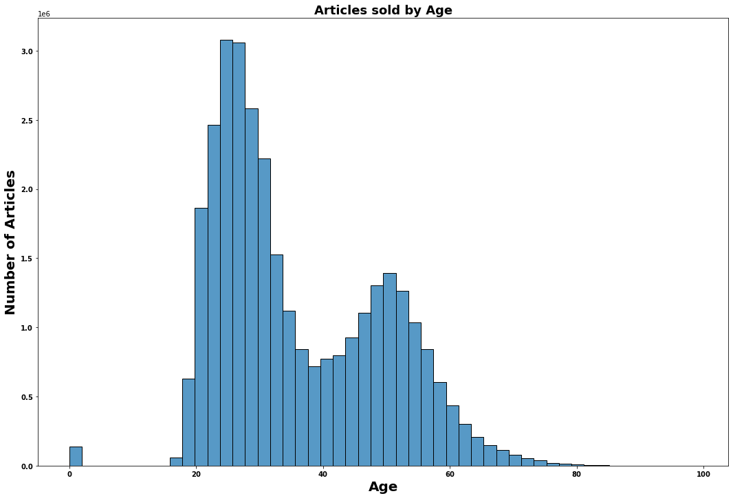

Figure 8. Articles Sold by age

The Figure 9 show that articles sold by product group and index group. Garment Upper body is the most popular product group, and in Garment Upper body, Ladieswear is the most chosen. Table 8 and Figure 10 show the total transaction amount by date. The result is basically the same as the previous total number of customers by date. The results show that days with more customers have higher sales.

Figure 9. Articles Sold by product group and index group

|  |  |
| --- | --- |
| date | Total transaction |
| 2019-09-28 | 6161.603068 |
| 2020-04-11 | 4444.342390 |
| 2019-11-29 | 4071.381305 |
| 2018-11-23 | 3961.987763 |
| 2018-09-29 | 3891.939441 |

Table 8. Top 5 of total transaction by date

Figure 10. Transaction amount by date

Figure 11 shows the frequency of fashion news. Most customers choose none. Figure 12 shows the status of club member. Most customers are active members.

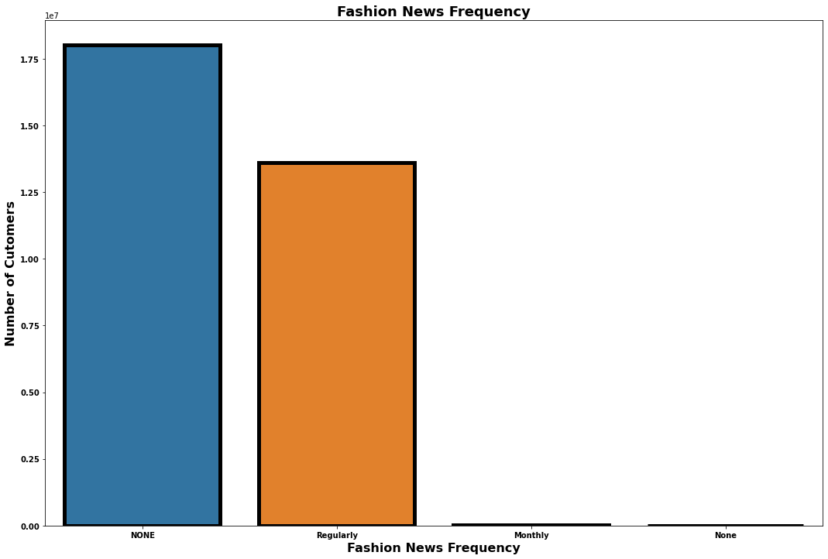

Figure 11. Fashion News Frequency

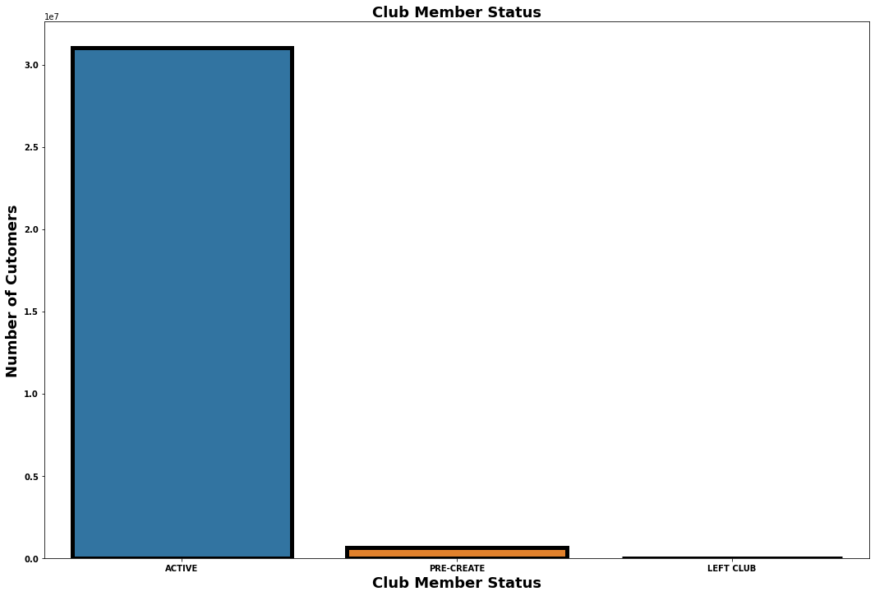

Figure 12. Club Member Status

To understand the reasons that affect the number of product purchasers, this project analyzes the correlations of each value. We first calculated the total number of customers for each item, and then exported a new data set table. We checked outliers again through the new data table (Figure13). Figure 14 and Figure 15 show the results about the correlation of the total customer table. The results show that product code is the most influential factor. Product code has a negative correlation with the number of customers, on the contrary, the price has a positive correlation with the number of customers.

Figure 13. Box plot of total customer table

Figure 14. Correlations of total customer table

Figure 15. Correlations about total customer

Finally, we use the Word Cloud to analyze the describe of the product detail. The figure 16 show the results. The “Top”. “Front”, and “back” are the most use word in the product detail.

文本

Figure 16. Word cloud for description

**V. Modeling**

Apache Spark is an open-source distributed query and processing engine that provides the flexibility and scalability of MapReduce with faster speed, and users can read, transform, and aggregate data to train and design complex statistical models by Spark (Drabas et al., 2017). In this project, we use PySpark to design models and analyze data. PySpark allows interaction via notebooks like Jupyter or Databricks (Drabas et al., 2017). We use Jupyter and Python to complete the code part of this project.

Alternating Least Squares (ALS) is a matrix factorization algorithm that runs in parallel, ALS can be used in Apache Spark ML for large-scale collaborative filtering problems (Liao, 2018). ALS decomposes the given matrix into two factors U and V such that The column of the user matrix is denoted by and could be called the rating matrix with , therefore the following problem is solved by (Apache Flink 1.2 Documentation, 2022):

According to the pyspark manual, the team choose to use ALS function under the pyspark package. For better evaluating the model, the team used the regression evaluator. Also, the team used paramGridBuilder to tune the model(Figure 16).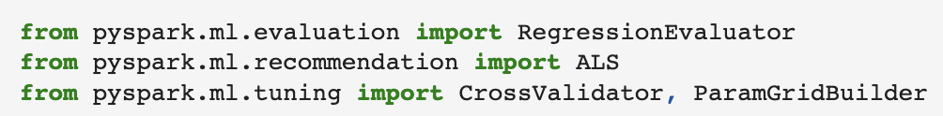

Figure 16. Modeling package usage

For the code implementation, the team picked “rank”, “maxIter”,and “regParam” to tune the model so far(Figure 17). More changes would made when the team find the new key parameter. Also in the Figure 17, the team try to use RMSE and Cross Validation to evaluate the model.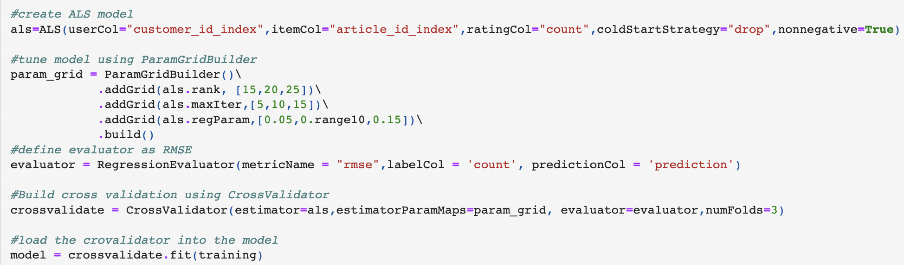

Figure 17. Modeling code implementation

After a series of test, the team choose a best model and achieved a list of RMSE and related parameters(Figure 18):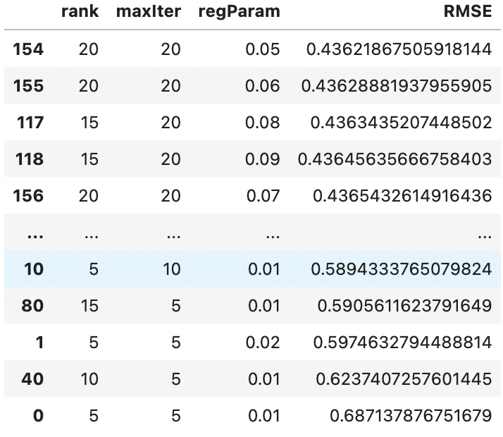

Figure 18. Evaluation result and related parameters

**VI. Results**

With a list of data transformation and visualization, the team received a list which covers the id of each customer and related article id(Figure 19).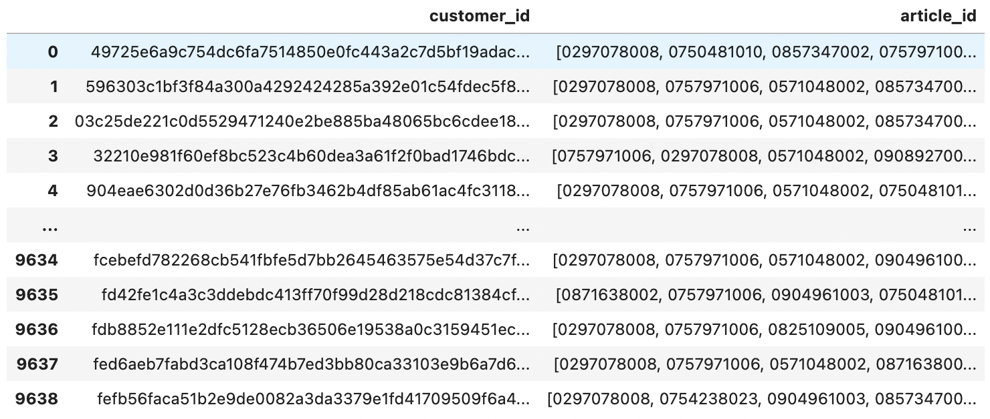

Figure 19. A glance of recommendation of result

The model merged a relatively larger list which covers 29485 recommendation into a list based on the list of customer ID.

In Order to visualize our recommendation result, the group decide to present the image of the article which related to the article_id. After the tokenizing the data frame, the group generate the function to scrap the recommendation of each customer(Figure 20).

Image

Figure 20. Recommendation for customer 0

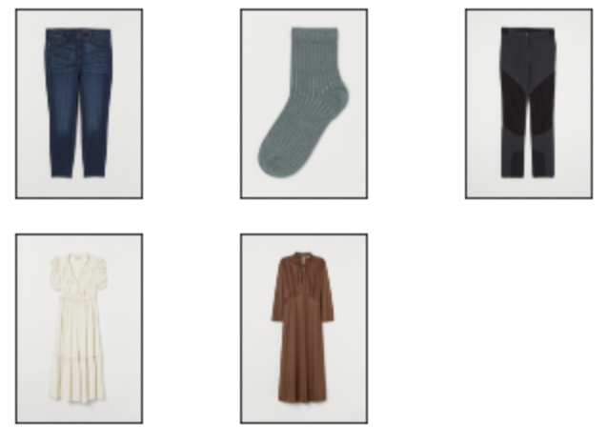

Figure 21. Visualization of recommendation for customer 0

After that, the group could link the image dataset to the recommendation result(Figure 21). Therefore, the future customer could see the recommendation result by using image.

**Reference:**

Zhao, Xuesong. “A Study on e-Commerce Recommender System Based on Big Data.” *2019 IEEE 4th International Conference on Cloud Computing and Big Data Analysis (ICCCBDA)*, 2019,<https://doi.org/10.1109/icccbda.2019.8725694>.

Jessica Young | Feb 18, 2022, et al. “US Ecommerce Grows 14.2% in 2021.” *Digital Commerce 360*, 16 Sept. 2022,<https://www.digitalcommerce360.com/article/us-ecommerce-sales/>.

“H&M Personalized Fashion Recommendations.” *Kaggle*, https://www.kaggle.com/competitions/h-and-m-personalized-fashion-recommendations/data.

Drabas, Tomasz, et al. *Learning Pyspark: Build Data-Intensive Applications Locally and Deploy at Scale Using the Combined Powers of Python and Spark 2.0*. Packt Publishing, 2017.

Liao, Kevin. “Prototyping a Recommender System Step by Step Part 2: Alternating Least Square (ALS) Matrix Factorization in Collaborative Filtering.” *Medium*, Towards Data Science, 19 Nov. 2018, https://towardsdatascience.com/prototyping-a-recommender-system-step-by-step-part-2-alternating-least-square-als-matrix-4a76c58714a1.

“Alternating Least Squares.” *Apache Flink 1.2 Documentation: Alternating Least Squares*, 19 Oct. 2022, https://nightlies.apache.org/flink/flink-docs-release-1.2/dev/libs/ml/als.html.